We seen difference in Gui of NoSUP (only Supervision/Monitoring portal for CATS as of now, which in turn using the Zabbix tool) from Wed,26th Jan 2022:

In the Previous times, we used to have CI, Time of Suppression & Remarks in one single page under Menu – “Nosup” and for checking the monitoring suppressions already in place (listing), we used to check it in the same menu.

Now its separated and both coming under – “CareMa (Nosup) “

Home Page:-

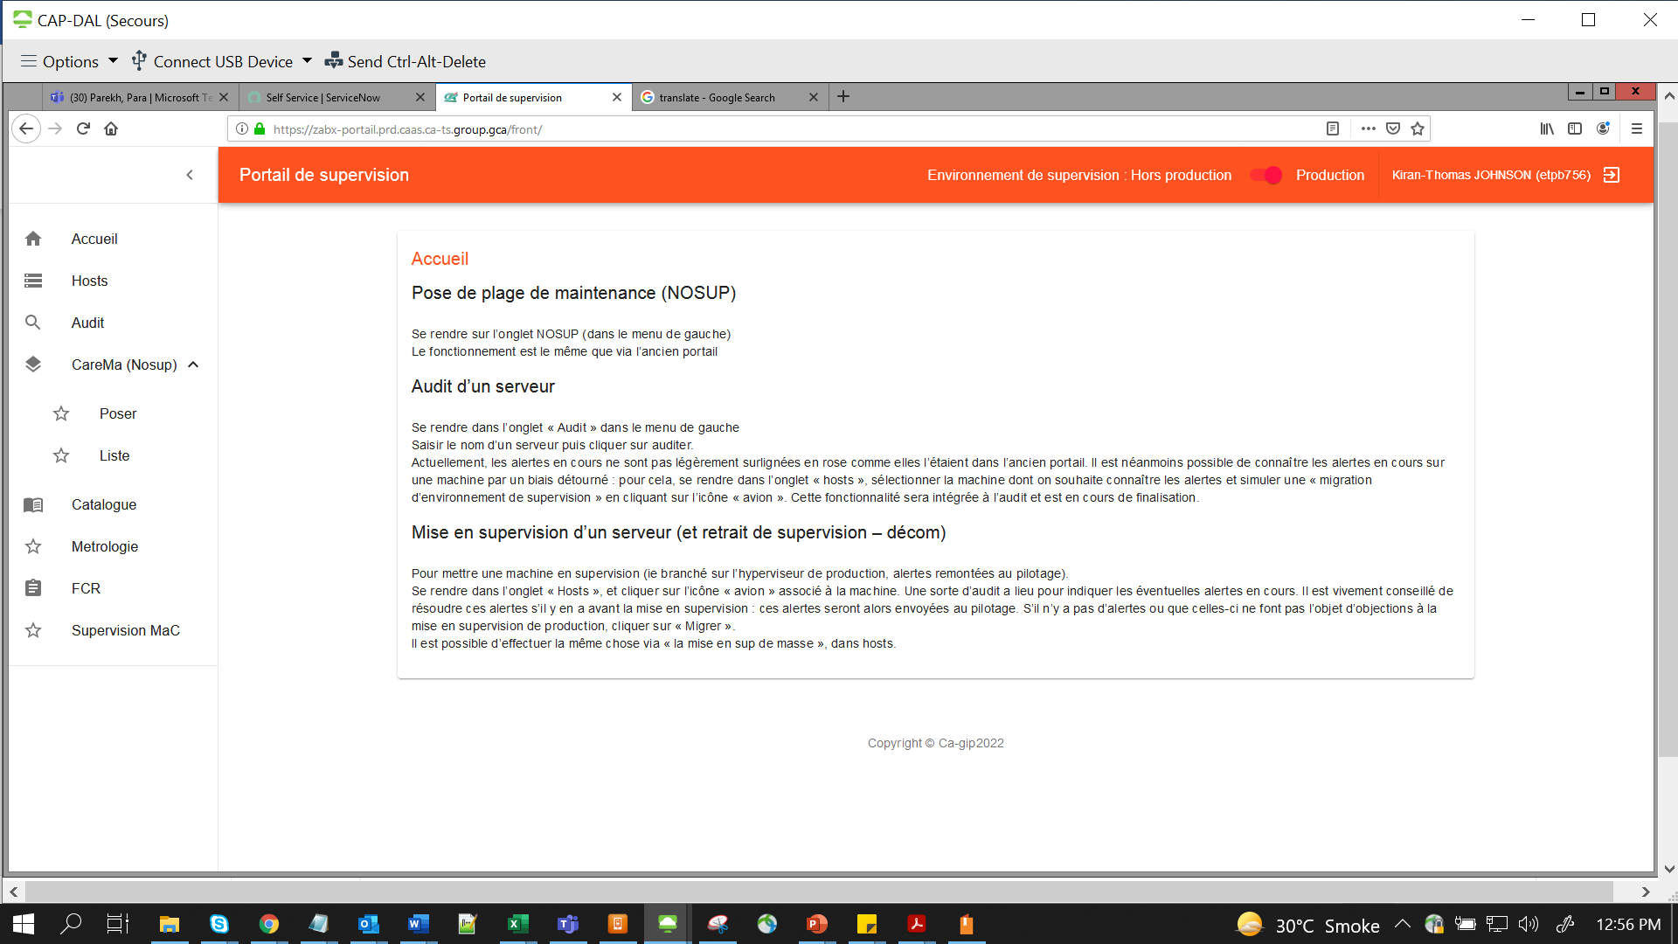

For creating a new Suppression entry:- go to **CareMa -> Poser**

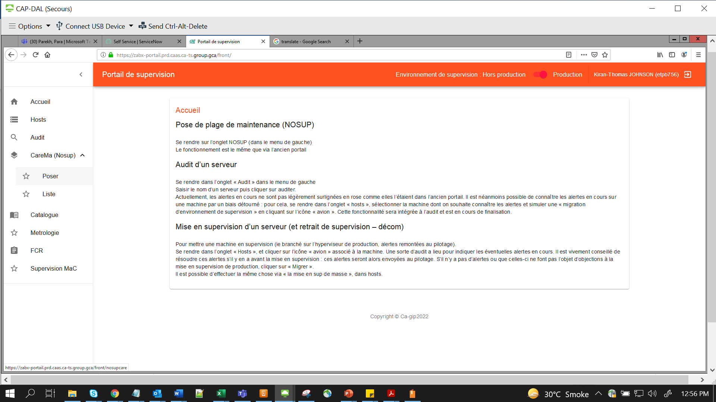

This is where we need to define CI (s) { Multiple CI’s can be put up in comma separated format}

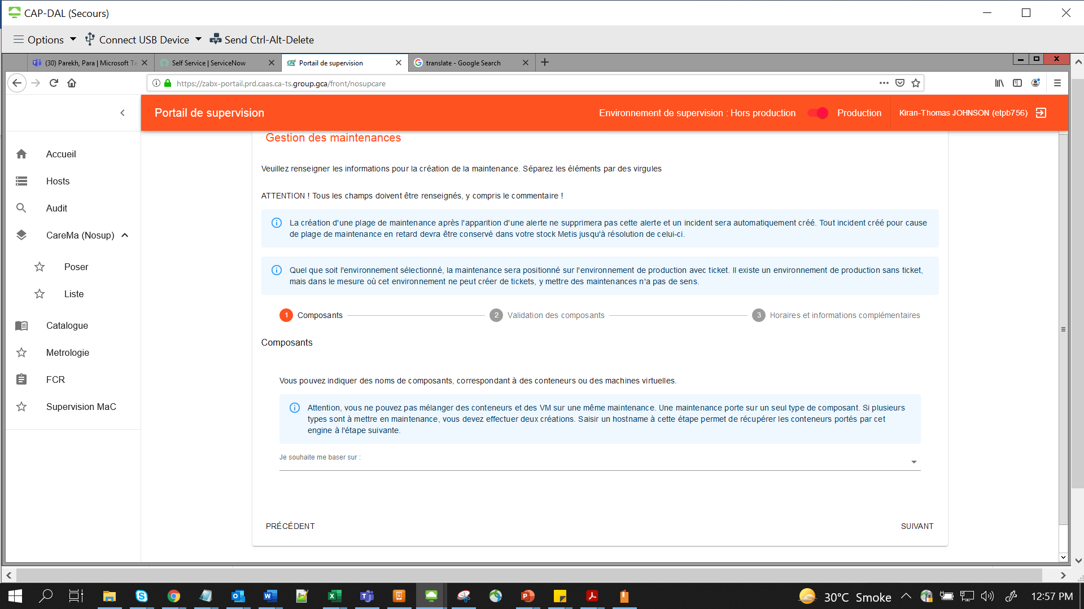

Select first item in dropdown (Second item is for Application Code, may be for suppressing all CI’s under an Apps code)

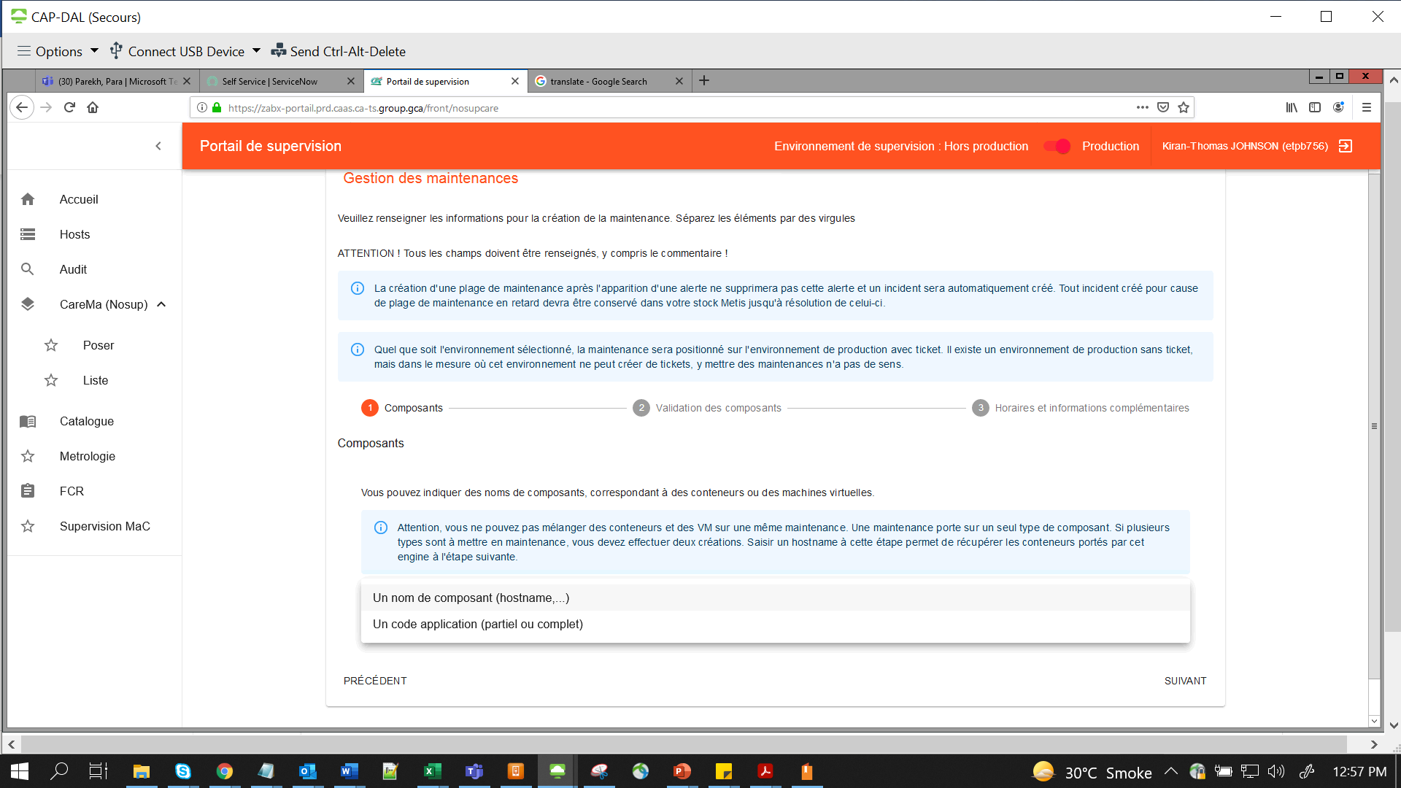

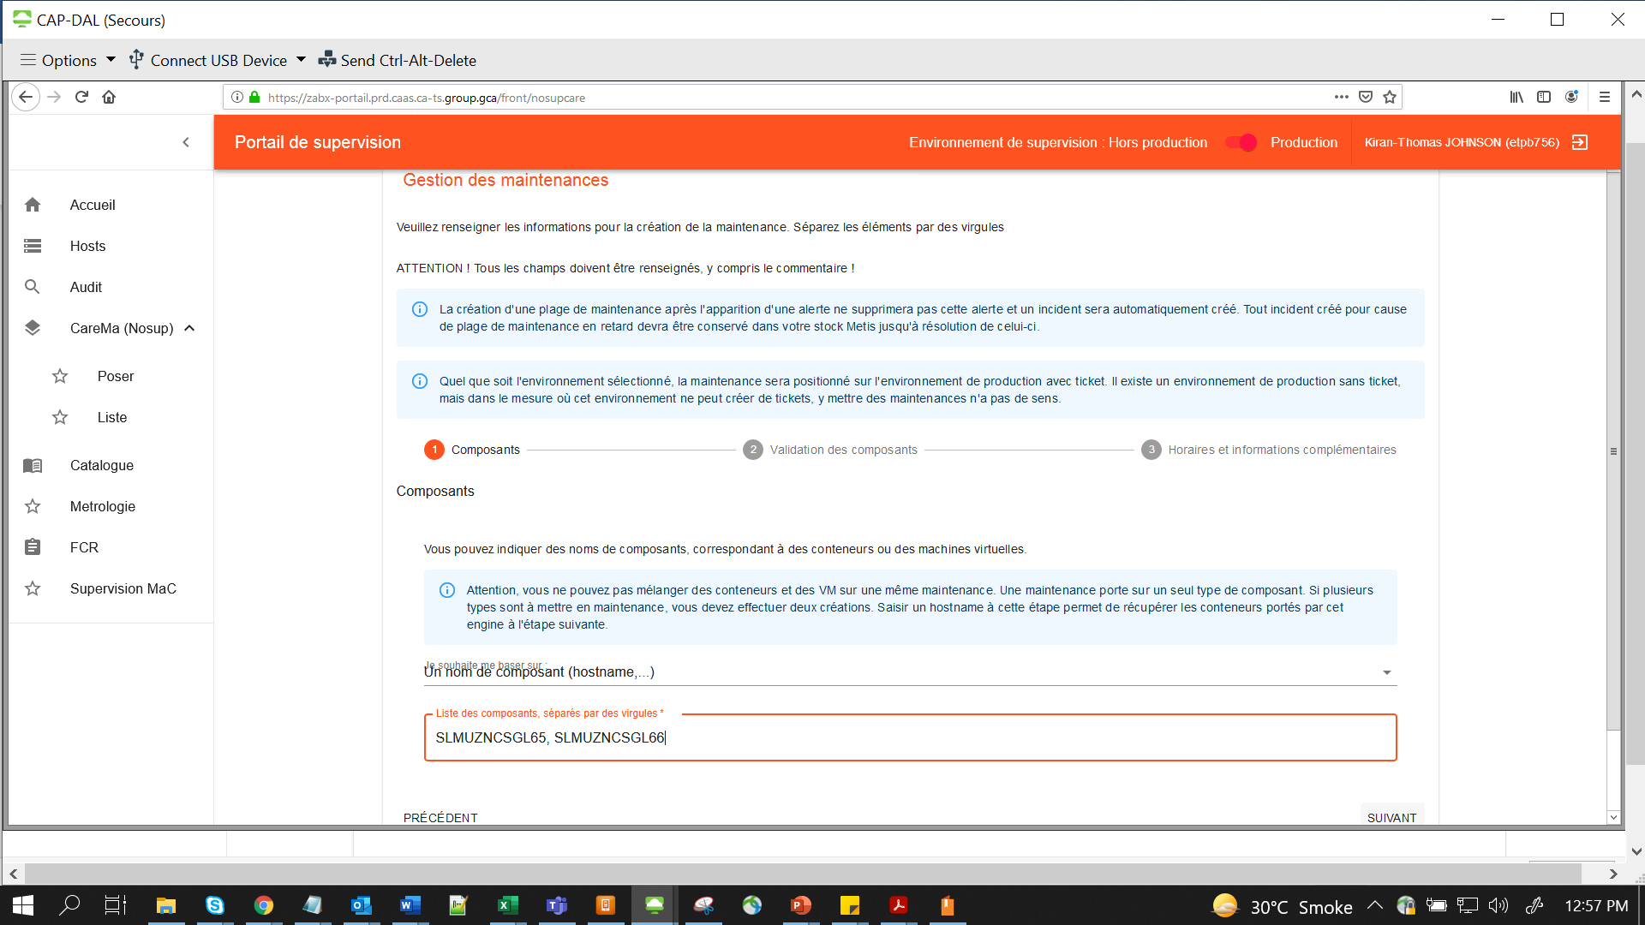

Suivant 🡺 Save & Next

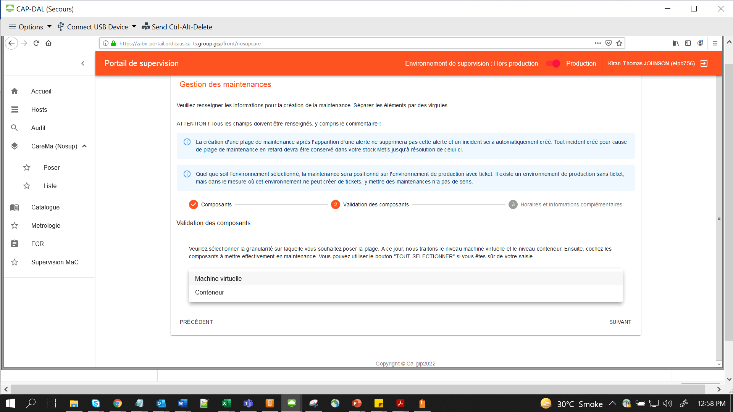

**NB:- We tested with both Machine Virtuelle (Virtual Machine) & Conteneur (Container) for these Physical Hosts – SLMUZNCSGL 65, 66 and suppression is applied. So apart from VM’s we can select Conteneur.**

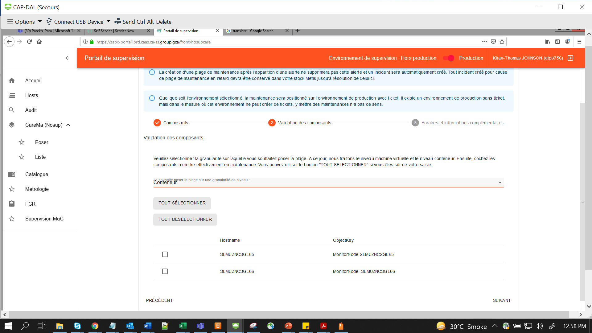

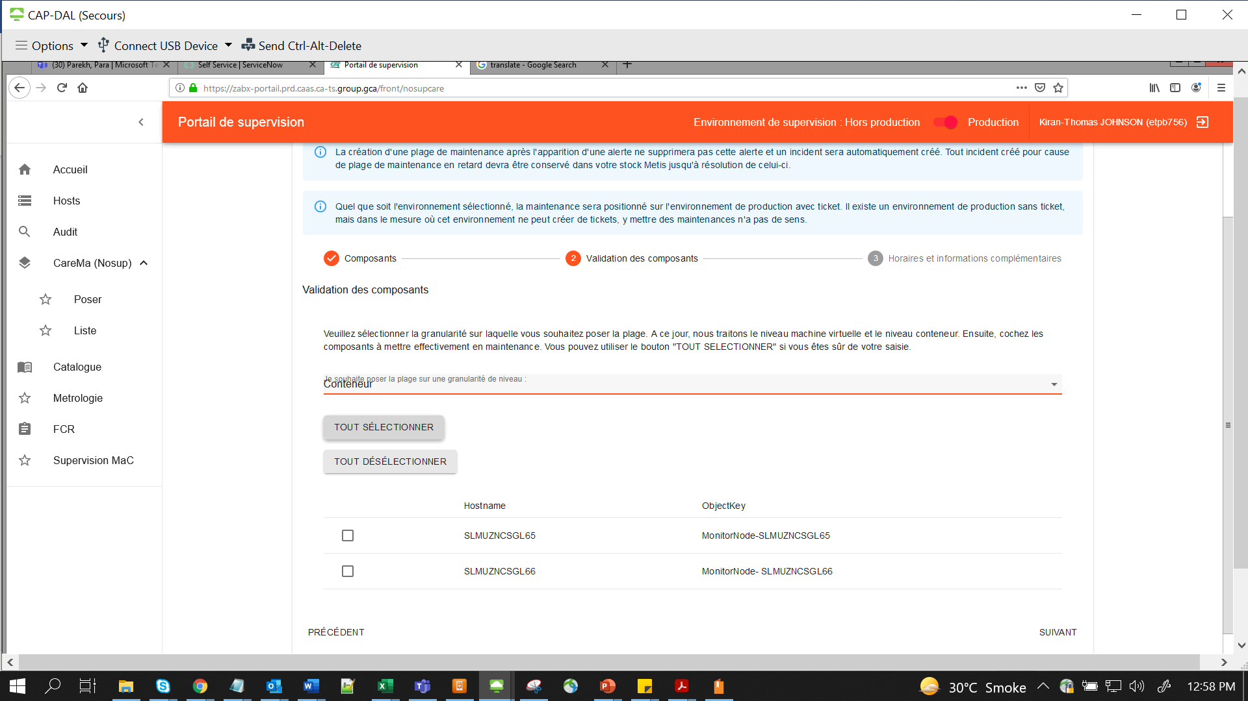

**Tout Selectionier => Select All**

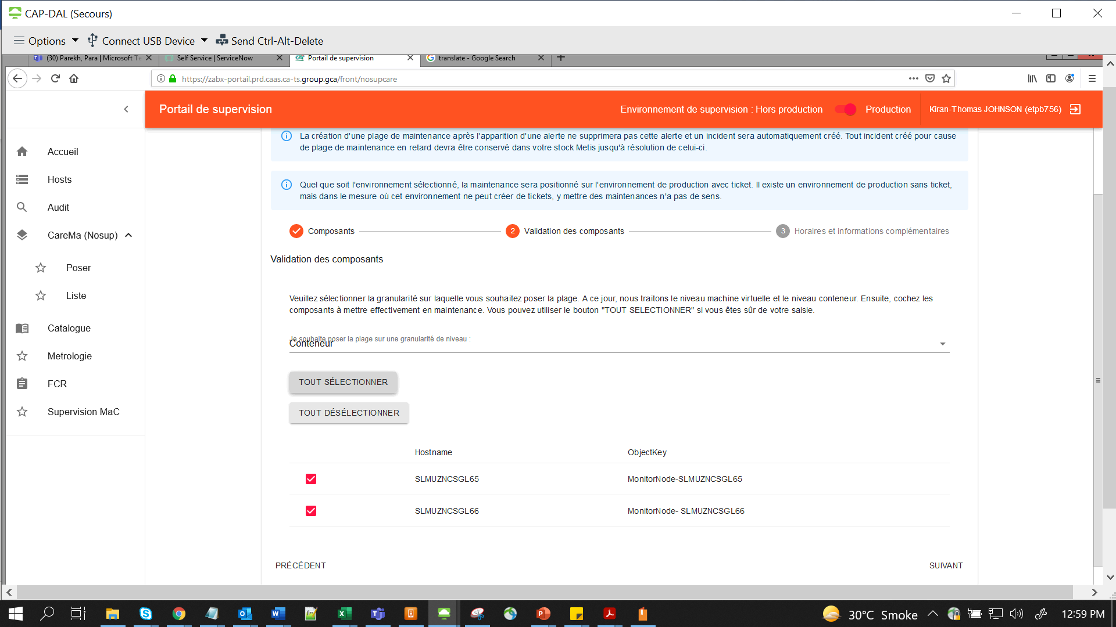

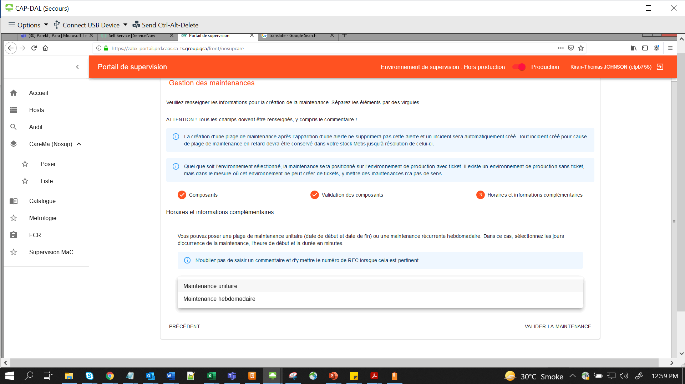

**For One day or for one timeframe => Select first item (For multiple days or weeks like in the case where we follow cool off period for Decom’s, select second item in dropdown)**

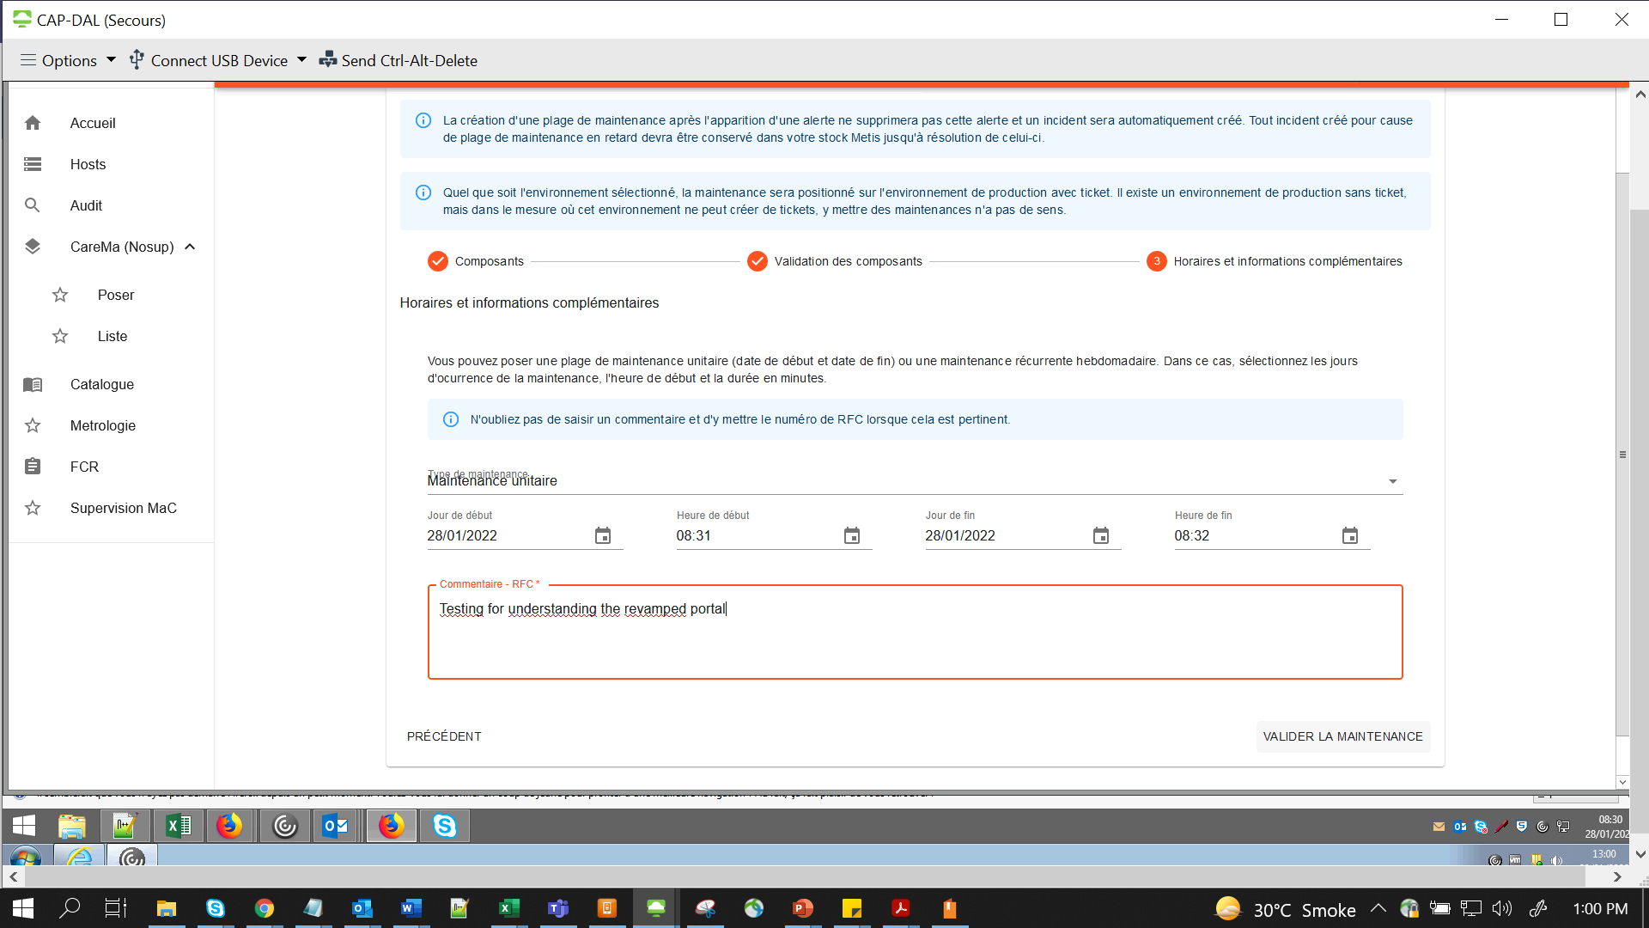

**NB:- Always give the Comment/Reason with a valid justification – Change # or a Metis Ticket # in the Commentaire-RFC field**

**Click Radio Button “Valider La Maintenance” for creation**

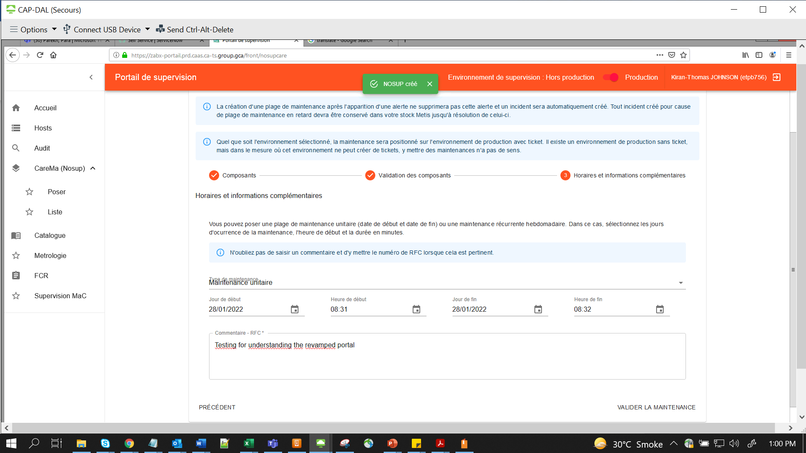

**Nb:- Once U clicked it & once U see the green popo up messaged at top of page, “Its Created”. Don’t again click on Valider radio button**

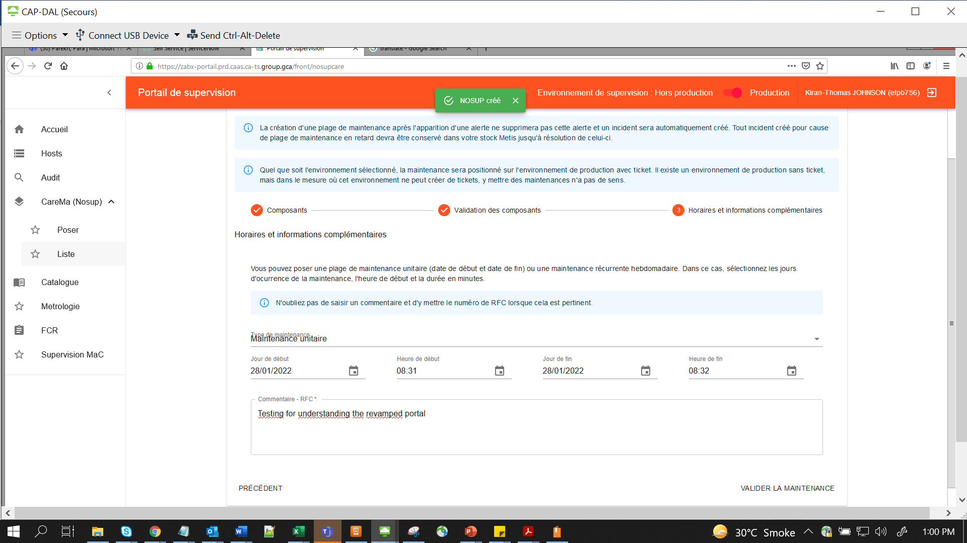

For checking(listing), go to **CareMa-> Liste**

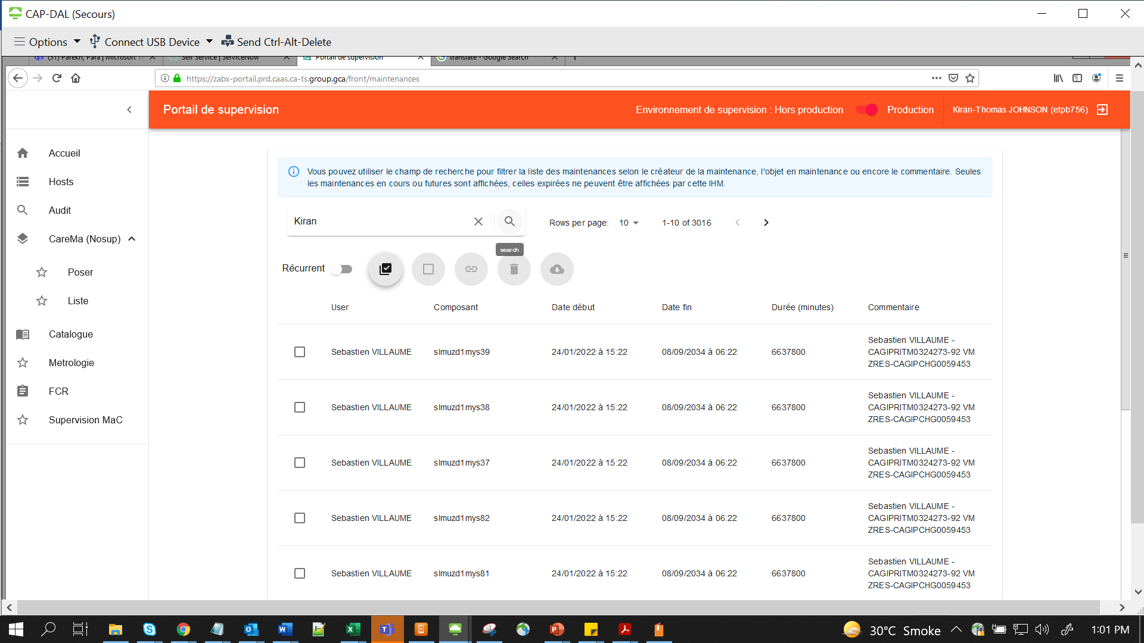

Search can be done with ur name or CI name

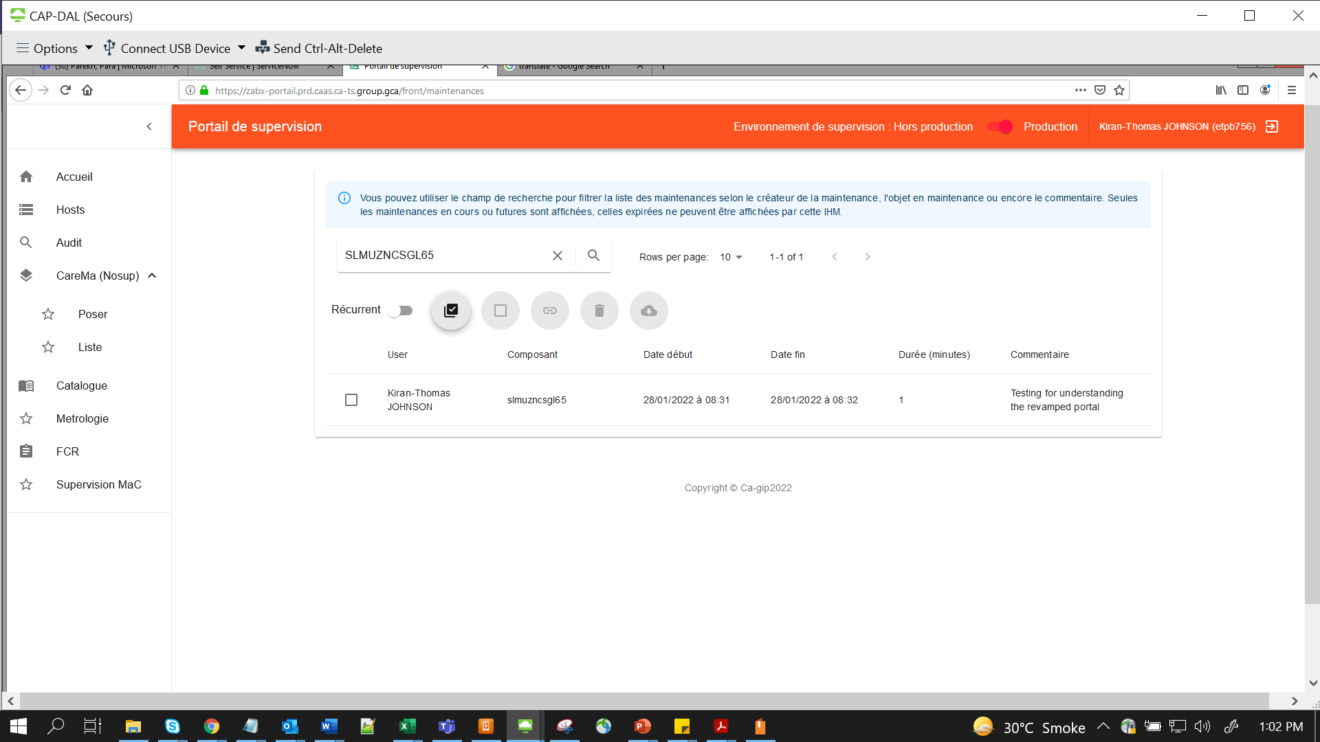

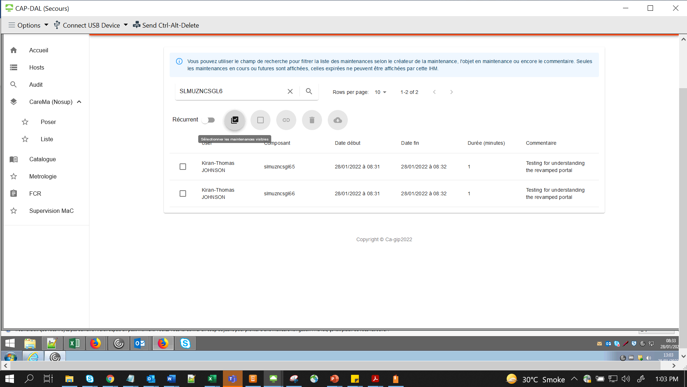

For selecting multiple entries – click on item near recurrent flipbox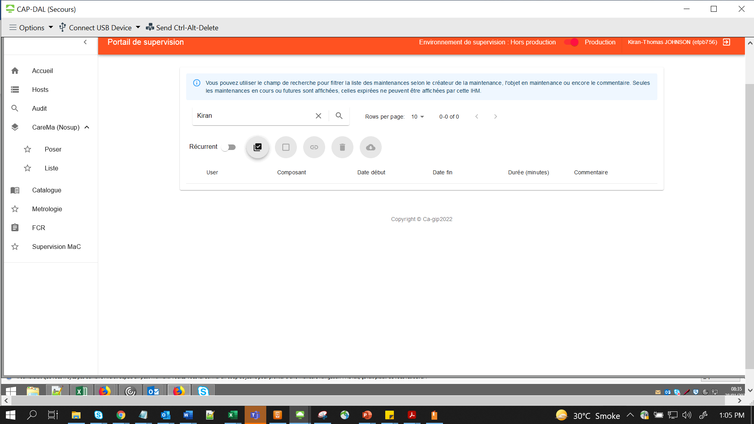

**V.IMP – if Supervision is done or our downtime activity is over, make sure to start Supervision again by deleting the entry in NoSUP**

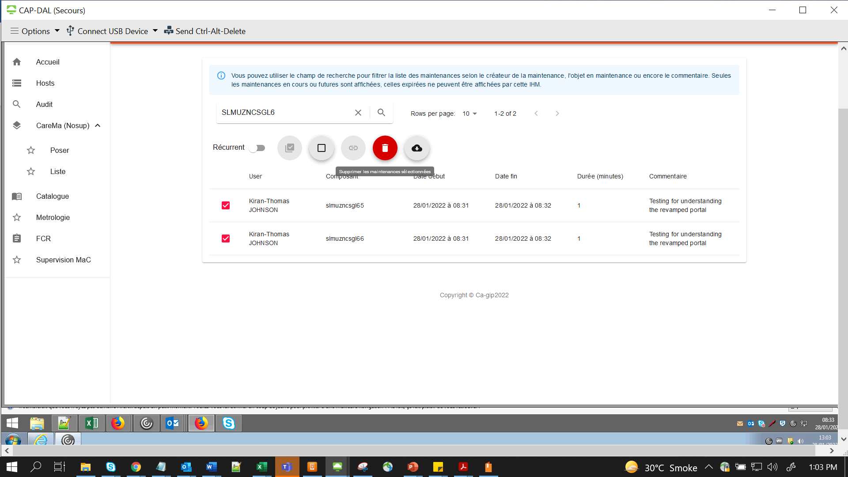

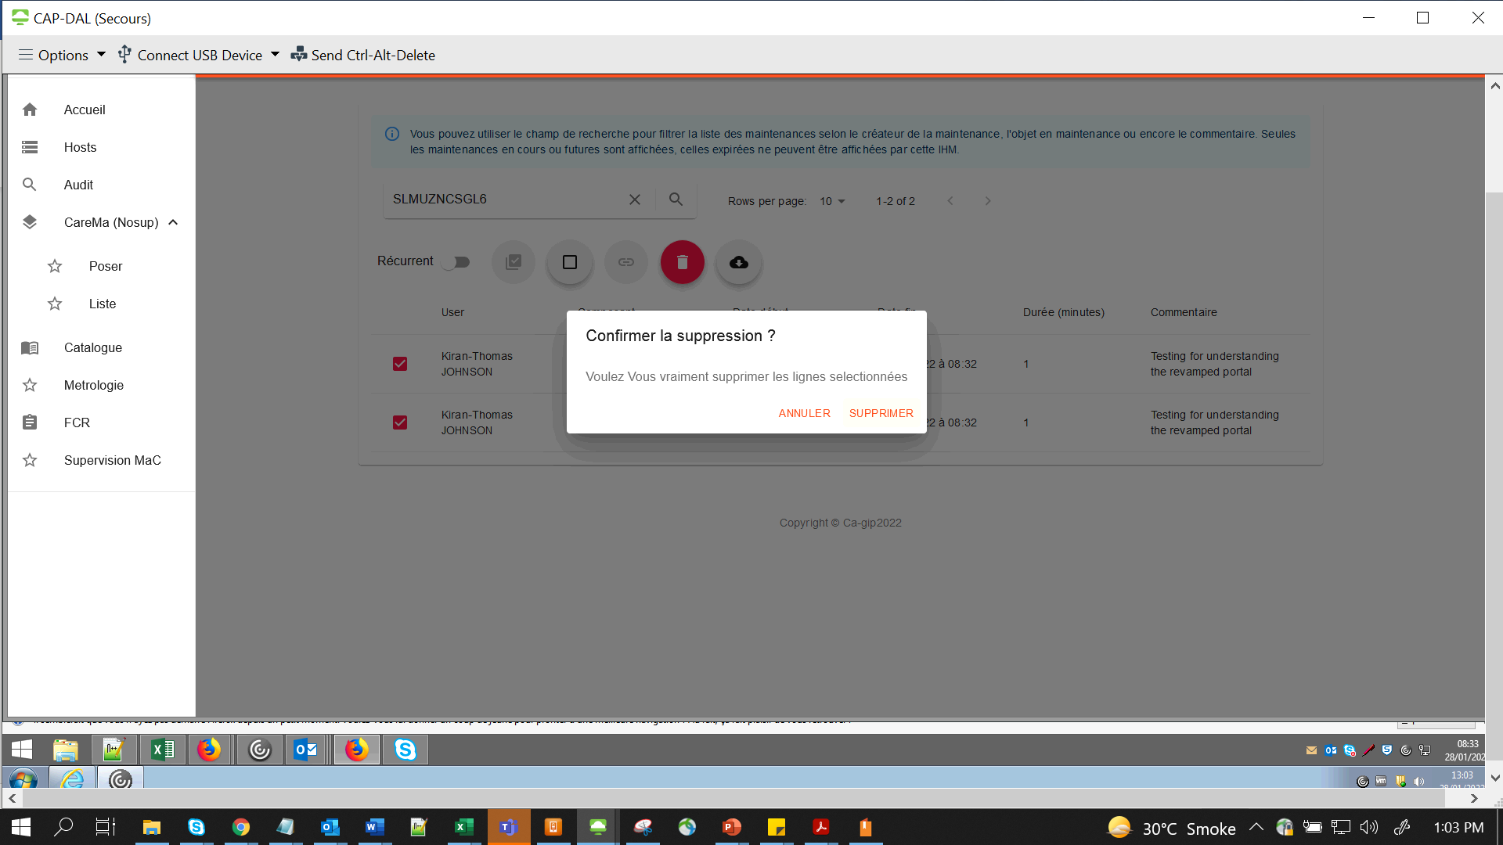

Click **Supprimer for Deleting**



**Make sure the entries are deleted by searching again**

**Word of Caution:-**

**If in the main Liste, by any chance if U select all, the Delete button will be enabled, and if U press enter or so, it may delete all Supervision stoppage for all CI’s done by All members. SO, PLEASE BE VERY CAREFUL and if U selected it by mistake U can unselect it all by clicking the very next button as shown below:**

